Lab report no: 02.

Lab report name: Basic command lines of linux operating system.

Objectives: understanding the usage of command lines in linux operating systems.

Name: Md. Harun Mia.

ID: IT-17032.

First question: what is linux command???

Answer:

Command lines run any software or folder or files. It is indicator line to run a software. Without mouse, we can run our computer by using command lines from our keyboard.

Second question: determinate 15 command lines of linux operating system.

Answer:

01. ls.

02. cd.

03. mv.

04. man.

05. mkdir.

06. rmdir.

07.touch.

08. rm.

09. locate.

10. clear.

11. bush

12. arch

13. df

14. atq.

15. cat.

Third question: basic command lines screenshot of linux operating system.

Answer:

Bash command line:

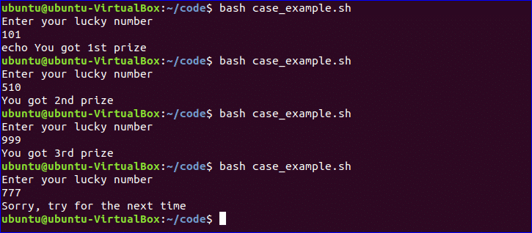

Cat command line:



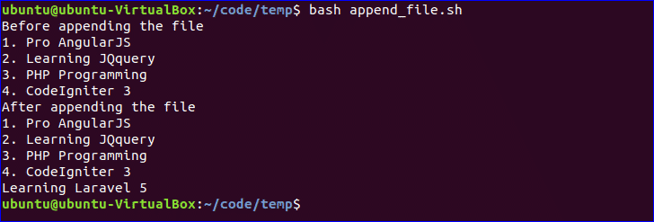

Ls command line:

